EXP 26:CREATE A SQL STORAGE SERVICE AND PERFORM A BASIC QUERY USINGANY PUBLIC CLOUD SERVICE PROVIDER (AZURE/GCP/AWS) TO DEMONSTRATE DATABASE AS A SERVICE (DAAS)

AIM: CREATE A SQL STORAGE SERVICE AND PERFORM A BASIC QUERY USINGANY PUBLIC CLOUD SERVICE PROVIDER (AZURE/GCP/AWS) TO DEMONSTRATE DATABASE AS A SERVICE (DAAS)
PROCEDURE:
Step 1: Log in to Azure Portal
- Open https://portal.azure.com
- Sign in using your Azure student or free account.

Step 2: Create a Resource Group
- Search for “Resource Groups” in the search bar.
- Click Create → enter details:
  - Resource Group Name: SQLGroup
  - Region: Choose nearest region (e.g., East US, Central India).
- Click Review + Create → Create.

Step 3: Create an Azure SQL Database
- In the search bar, type “SQL Database” → Click Create.
- Fill details:
  - Subscription: Azure for Students / Free
  - Resource Group: SQLGroup
  - Database Name: StudentDB
- Under Server, click Create New Server:
  - Server Name: student-sqlserver
  - Server Admin Login: adminuser
  - Password: (enter a secure password)
  - Location: Same as resource group
- Click Next → Networking, then allow public access.
- Click Review + Create → Create.
Step 4: Configure Firewall Rules
- After deployment, open your SQL database → Click Set Server Firewall.
- Click Add Client IP to allow your computer to access the database.
- Click Save.

Step 5: Query the Database (Using Query Editor)
- In the SQL database page, click Query Editor (Preview).
- Login with the admin username and password.

Step 6: Verify and Save Results
- Verify that the table and records are successfully created.
- Take a screenshot of:
  - Database creation summary
  - Query Editor results

Step 7: Stop/Remove Resources
- After completion, delete the Resource Group to avoid charges:
  - Go to Resource Groups → SQLGroup → Delete Resource Group.

OUTPUT:
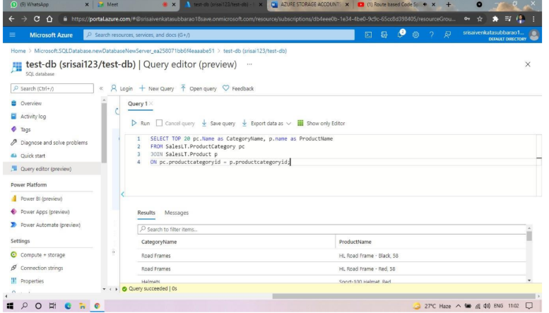

RESULT:
A SQL storage service was successfully created on Microsoft Azure, and basic SQL queries were executed using the Query Editor to demonstrate Database as a Service (DBaaS) functionality.

